* EDP
  + Sales And Expense Report
  + Update the Report Short and Over on Sales
  + 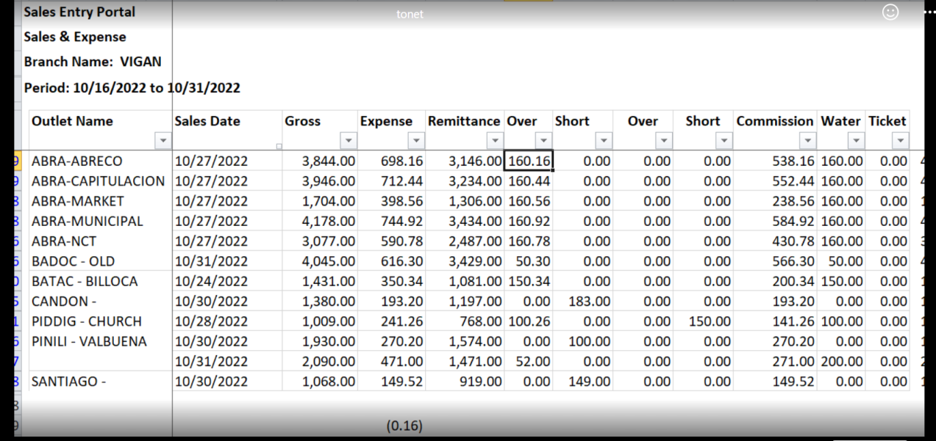
  + 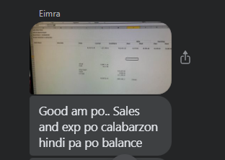
  + 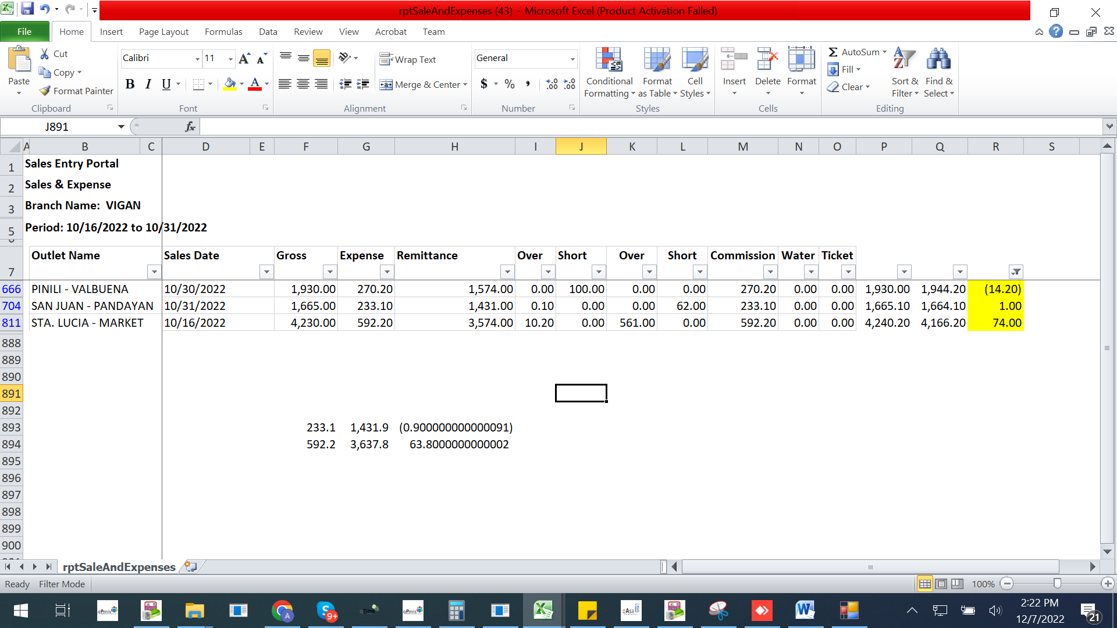
* DCRR Report
  + Fixed the bug where the outlet triangulo is missing from print out report
  + 
   